**King Saud University**

**College of Computer & Information Science**

**CSC111 – Tutorial05**

**Expressions, operators, conditional statement**

**All Sections**

**-------------------------------------------------------------------**

# Objectives:

1. Student should learn how to program using selection statements with combined conditions.
2. Student should learn how to combine conditions using logical operators (**!**, **&&**, and **||**)
3. Student should learn how to write expressions using the conditional expression

# Exercise 1

1. What is the output of the code in (a) and (b) if number is 30? What if number is 35?

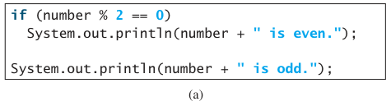

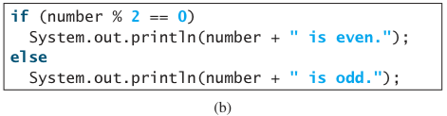

1. Two programs are equivalent if given the same input they produce the same output. Which of the following programs are equivalent? Why?

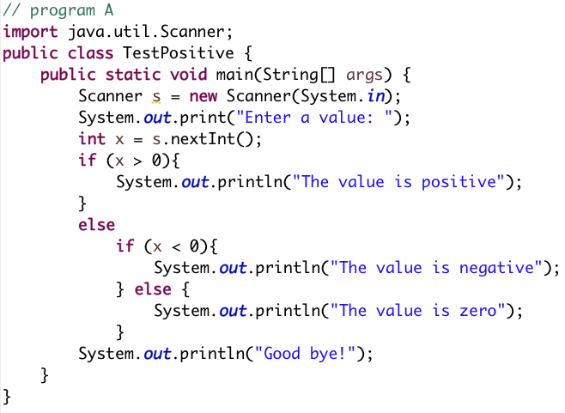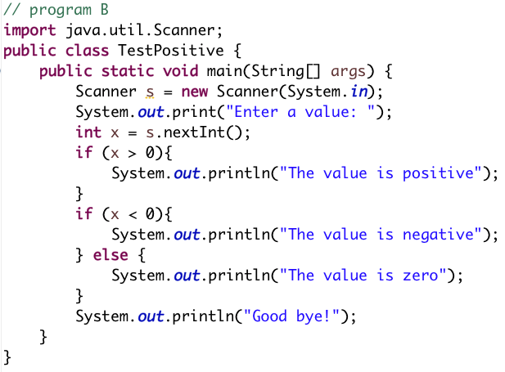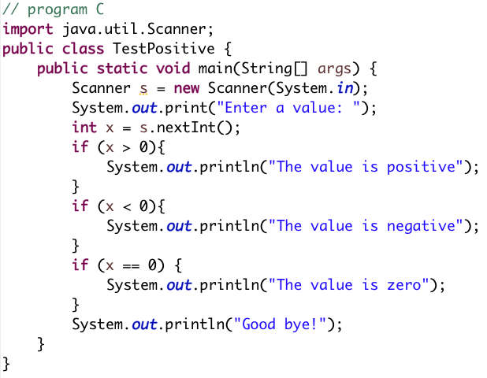

1. Suppose **x = 3** and **y = 2**; show the output, if any, of the following code. What is the output if **x = 3** and **y = 4**? What is the output if **x = 2** and **y = 2**?

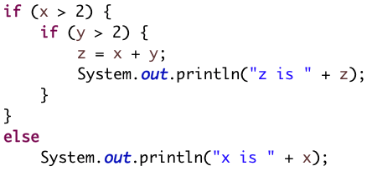

1. Assuming that **x** is **1**, show the result of the following Boolean expressions.
   1. (**true**) && (**3** > **4**)
   2. !(x > **0**) && (x > **0**)
   3. (x > **0**) || (x < **0**)
   4. (x != **0**) || (x == **0**)
   5. (x >= **0**) || (x < **0**)
   6. (x != **1**) == !(x == **1**)
2. Assume that **x** and **y** are **int** type. Which of the following are legal Java expressions?
   1. x > y > **0**
   2. x = y && y
   3. x /= y
   4. x or y
   5. x and y
   6. (x != **0**) || (x = **0**)

# Solution

a)

if number is 30 output is

30 is even.

30 is odd.

This is wrong output and caused by not using else.

if number is 35 output is

35 is odd.

b)

if number is 30 output is

30 is even.

if number is 35 output is

35 is odd.

1. Programs A and C are equivalent. Program B is different since it gives different output if input is a positive number grater than zero. For example, 3.

**x = 3** and **y = 2 🡺** no output

**x = 3** and **y = 4**

z is 7

**x = 2** and **y = 2**

x is 2

* 1. false
  2. false
  3. true
  4. true
  5. true
  6. true
  7. illegal
  8. illegal
  9. legal
  10. illegal
  11. illegal
  12. legal

# Exercise 2

Write a program that prompts the user to enter a three-digit integer and determines whether it is a palindrome number. A number is palindrome if it reads the same from right to left and from left to right.

Here are two sample runs:

Enter a three-digit integer: 123 **↵**

123 is not a palindrome

Enter a three-digit integer: 242 **↵**

242 is a palindrome

# Solution

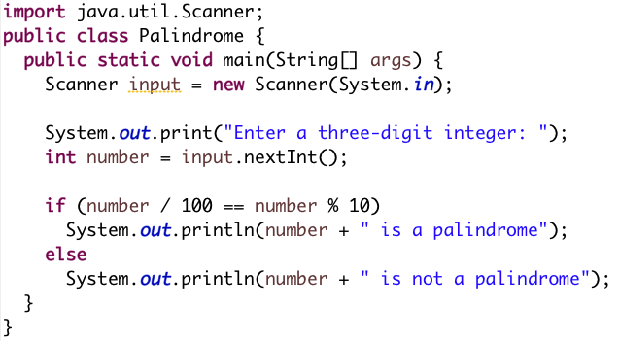

**Done…**